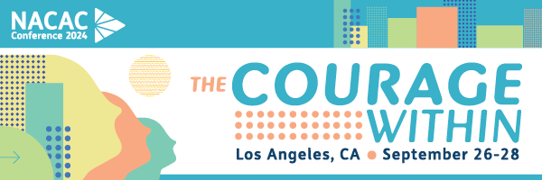
TO:
FROM:
SUBJECT: Why I should attend NACAC Conference 2024
NACAC Conference 2024 is the premier event for college admission counseling professionals that provides a variety of educational and networking opportunities. I would like to request approval to attend.
This year’s event offers access to 100+ education sessions, three (3) Main Stage sessions, networking with industry suppliers in the Expo Hall, and more. These sessions will cover the latest college admission counseling trends and insights and provide me with actionable takeaways to bring back to [insert institution/organization].
The event runs from September 26-28 at the Los Angeles Convention Center.
Here are the goals I plan to accomplish:
- Enter Goal #1
- Enter Goal #2
- Enter Goal #3
Here are the sessions I plan to attend (list sessions you plan to attend as well as learning objectives and indicate how they will benefit you and your institution):
I have calculated an approximate breakdown of costs associated with my attendance:
NACAC Conference 2024 Registration | $
Accommodations Estimate | $
Travel Estimate | $
Total Cost | $

I believe that my attendance at NACAC Conference 2024 will provide me with new ideas and strategies to improve our organization. After the event, I will provide a report of my key takeaways and share new ideas and strategies with the team. I will work to make sure we get the full value of the conference. Thank you for your consideration.
Sincerely,

